OS Lab – 7
Darshan J Patel
21BCE6061

1.
Code-
#include<stdio.h>

int main()
{
int lanes[4][3] = {{3,5}, {1,3}, {2,4}, {0,2}}; // Arrival and Crossing time for each lane
int current_lane = 0, total_wait_time = 0;

printf("Lane\tAverage Waiting Time\n");

for(int i=0; i<4; i++)
{
int waiting_time = 0;
if(i!=0) {
waiting_time += (lanes[i-1][1]-lanes[i][0]); // Calculate waiting time before starting the signal.
if(current_lane != i-1) {
waiting_time += 180; // If the previous lane is not adjacent to current lane, add 3 minutes to the waiting time.
}
}

// Print the average waiting time for the current lane
printf("L%d\t%.2f\n", i+1, waiting_time/2.0);

current_lane = i;
total_wait_time += waiting_time;
}

// Print the overall average waiting time
printf("\nOverall Average Waiting Time: %.2f\n", total_wait_time/8.0);

return 0;
}

Output-

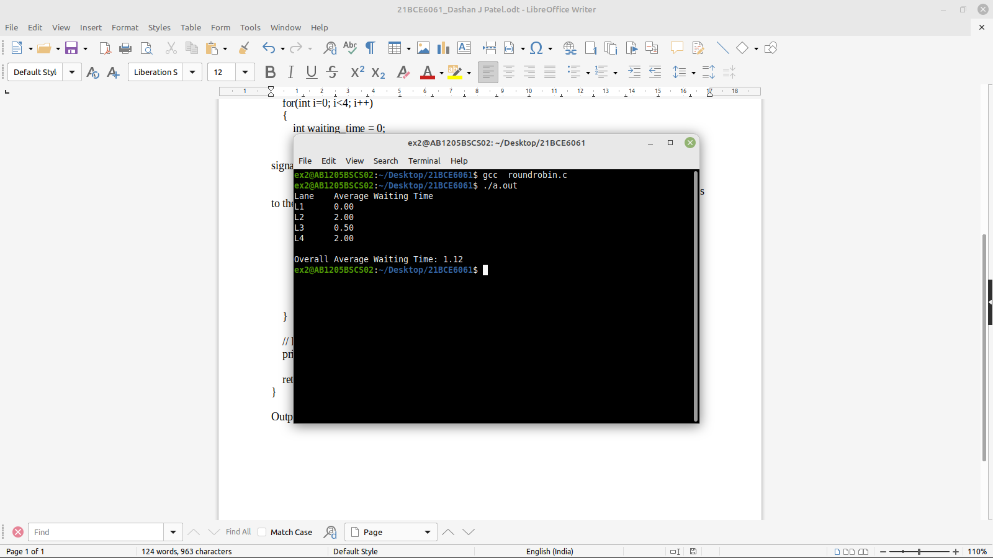
2.
#include<stdio.h>
#include<unistd.h>

int main() {
pid_t pid = fork(); // Create a child process

if(pid == 0) { // Child process
printf("Child process\n");
printf("Exiting...\n");
}
else { // Parent process
sleep(5); // Wait for 5 seconds before terminating the parent process
}

return 0;
}
Output-
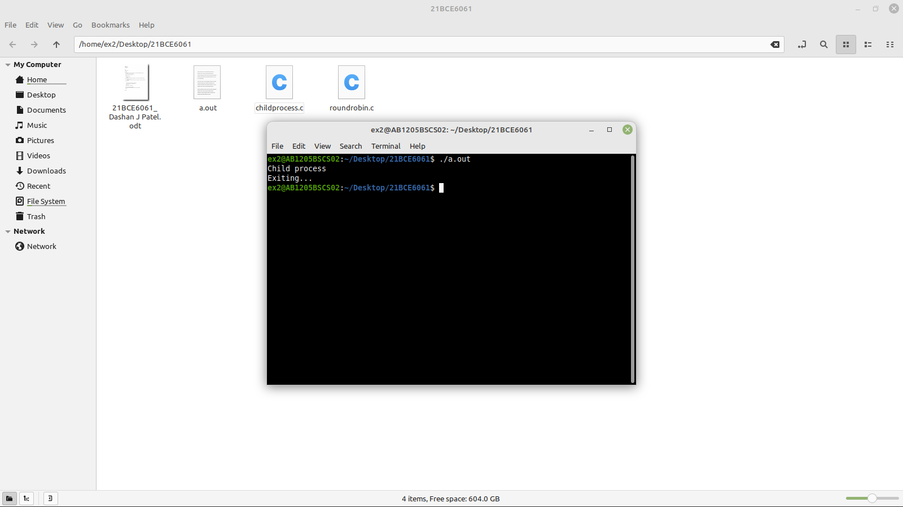
3.
#include <stdio.h>
#include <unistd.h>

int main() {
pid_t pid = fork();

if (pid == 0) { // child process
sleep(5);
printf("Child process %d\n", getpid());
printf("Parent process %d\n", getppid());
} else { // parent process
printf("Parent process %d\n", getpid());
sleep(2); // wait for 2 seconds
printf("Orphan process %d\n", getpid());
}

return 0;
}
Ouput-
